UML DIAGRAMS

CLASS DIAGRAM

Shows the system’s main classes such as User, Admin,Patient, Doctor, Staff, Appointment, Prescription, LabTest, Billing, Report,MedicalRecord, and CanteenOrder with their attributes and relationships. This diagram helps in understanding the overall structure of the HealCare system and forms the basis for database table design.
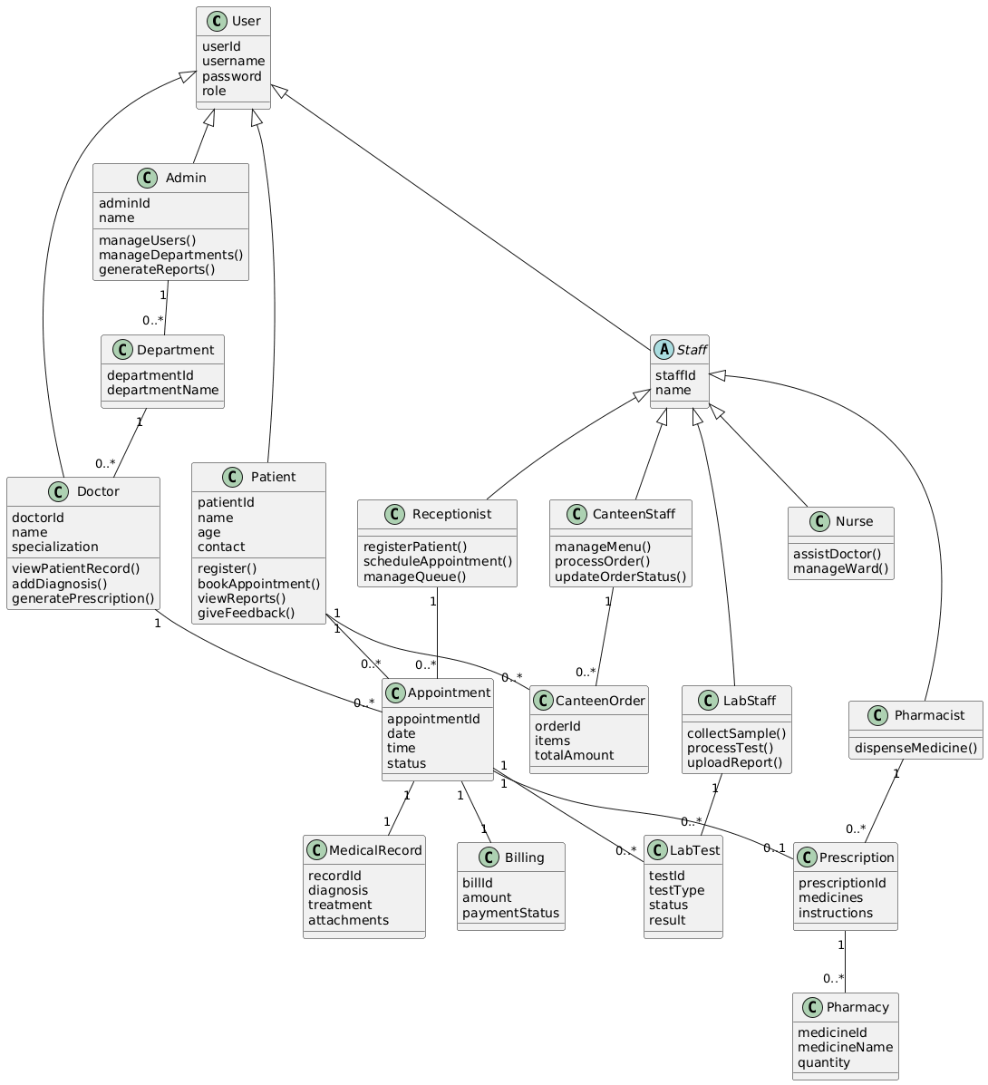

OBJECT DIAGRAM
Represents a snapshot of the system at a particular time. Example objects include a Patient object booking an Appointment with a Doctor, a generated Prescription, and a LabTest report, showing how real-time instances interact in HealCare.

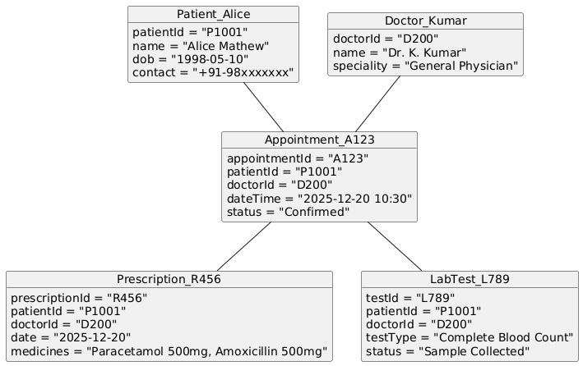

COMPONENT DIAGRAM

The component diagram displays the high-level modules of the HealCare system.
Displays high-level components such as Web Application, Authentication Service, Appointment Module, Medical Records Module, and Database. It provides a clear view of the system’s modular architecture.

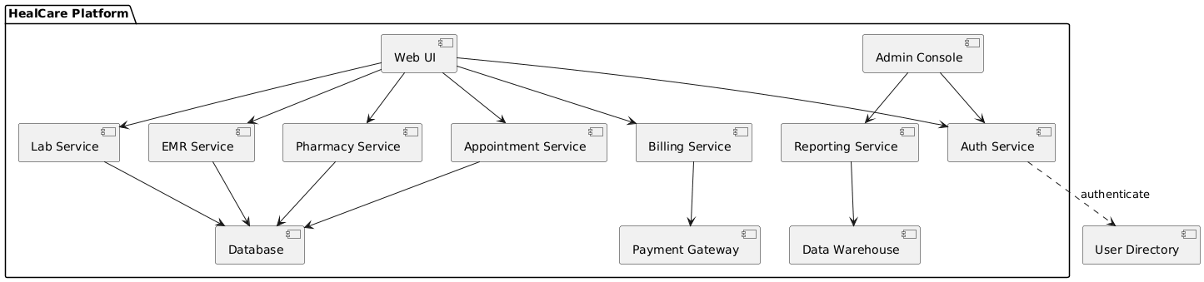

DEPOLYMENT DIAGRAM
Deployment diagram shows the physical architecture of the system,how the HealCare system is physically installed and accessed. Users (patients, doctors, staff, and admins) use a web or mobile interface connected to a web server, which forwards requests to the application server containing all healthcare modules.

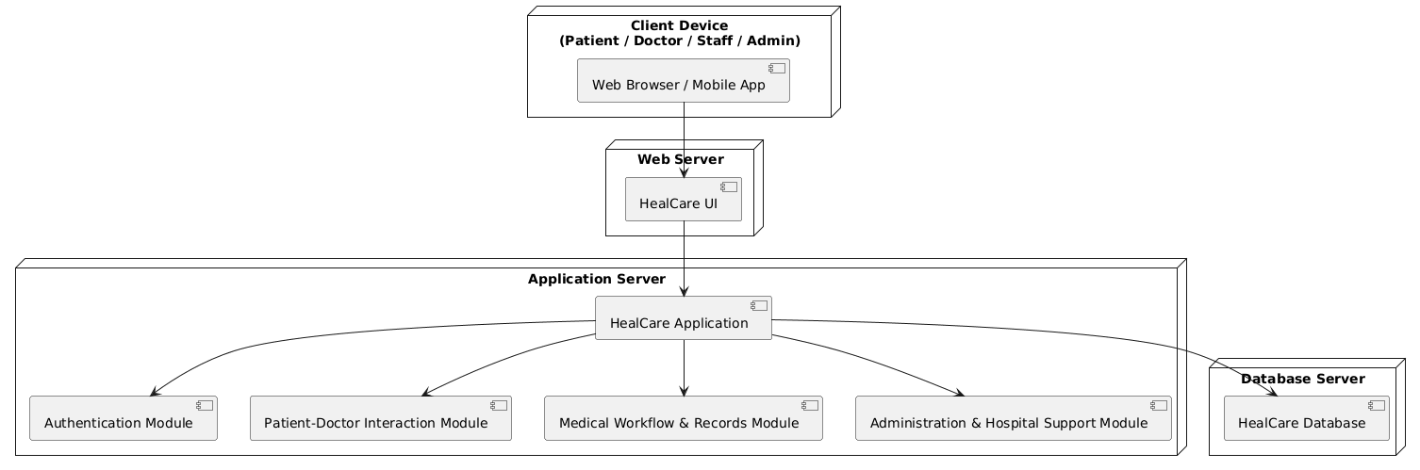

SEQUENCE DIAGRAM
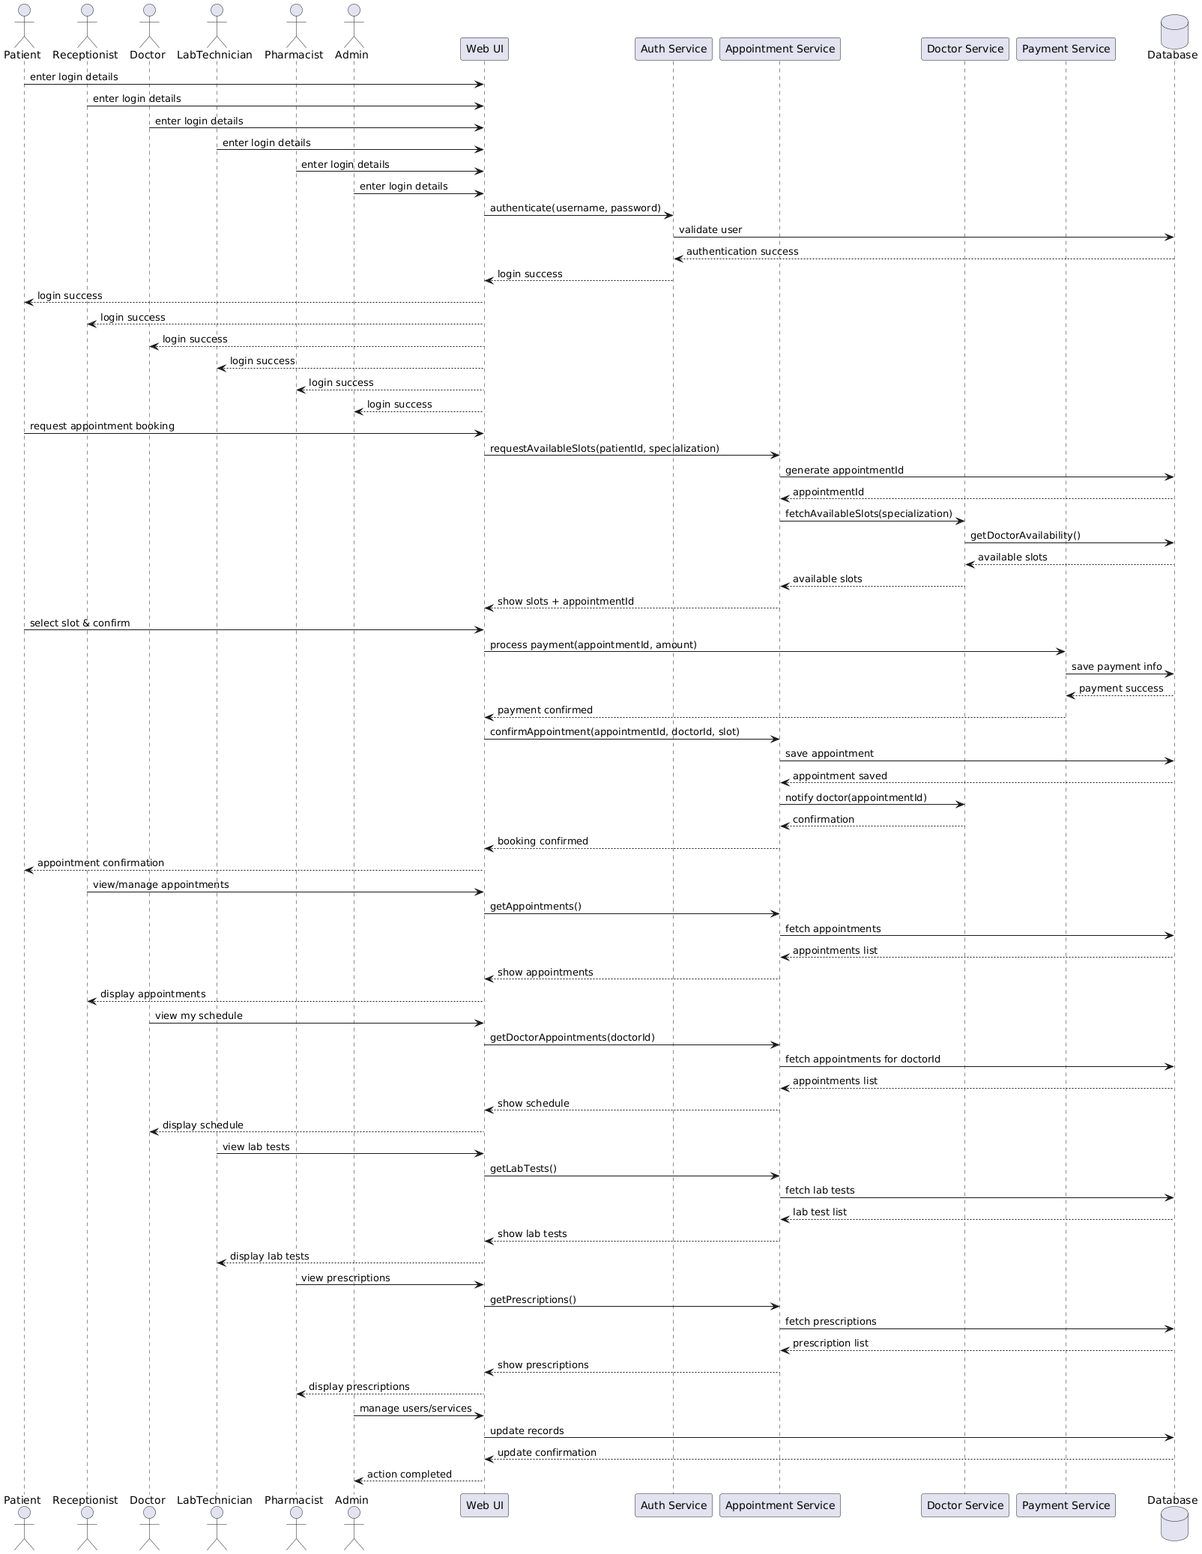
The sequence diagram shows the order of interactions over time. Shows the interaction flow for processes like appointment booking .It explains how requests move between the patient, system, doctor, and database in a time sequence.
STATE CHART DIAGRAM

Shows the various states of an appointment or patient visit such as Requested, Confirmed, In Consultation, LabOrdered,Prescription Issused,Billed,Paid, Completed, and Closed, along with transitions between these states.

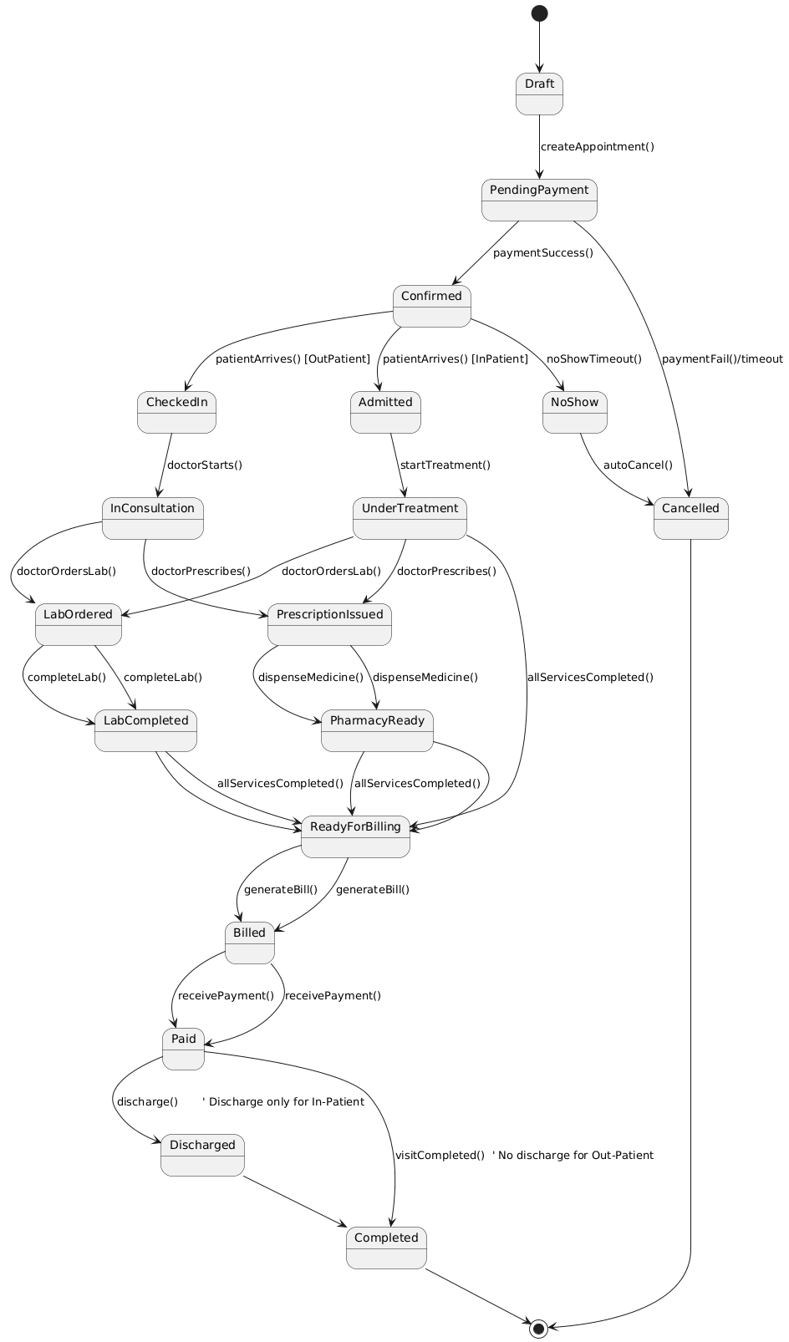

ACTIVITY DIAGRAM
Represents the workflow of patient care in HealCare. Activities include registration, appointment booking, Queue waiting, doctor consultation, lab testing or prescription, billing, and report generation.
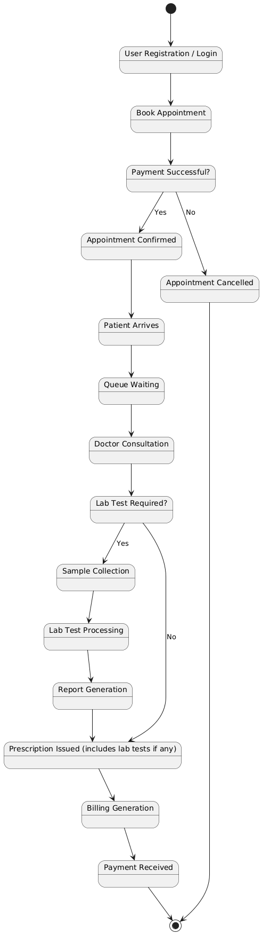

USE CASE DIAGRAM

Illustrates the interactions between actors (Patient, Doctor, Staff, Admin) and system functionalities such as registration, appointment booking, diagnosis entry, lab test requests, billing, report generation, and system administration.
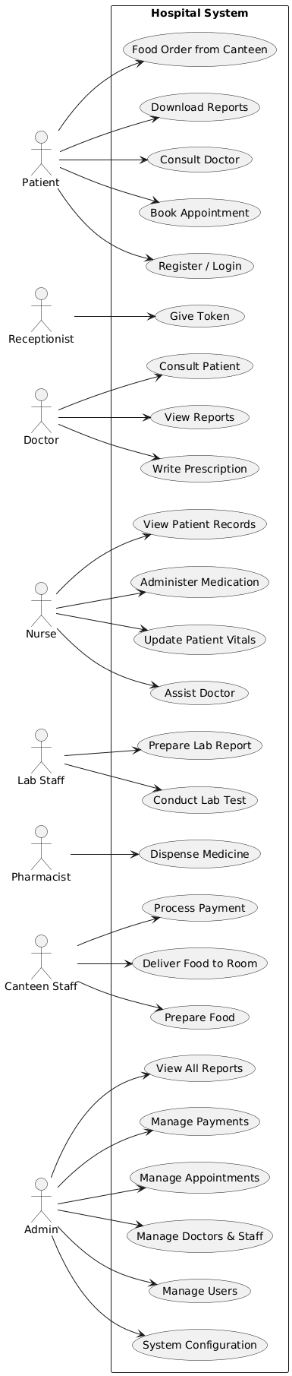

COLLABORATION DIAGRAM
Illustrates how system components collaborate to complete healthcare operations such as patient consultation. It focuses on message exchange between modules like Appointment Service, Lab Service, Medical Records,and Billing.

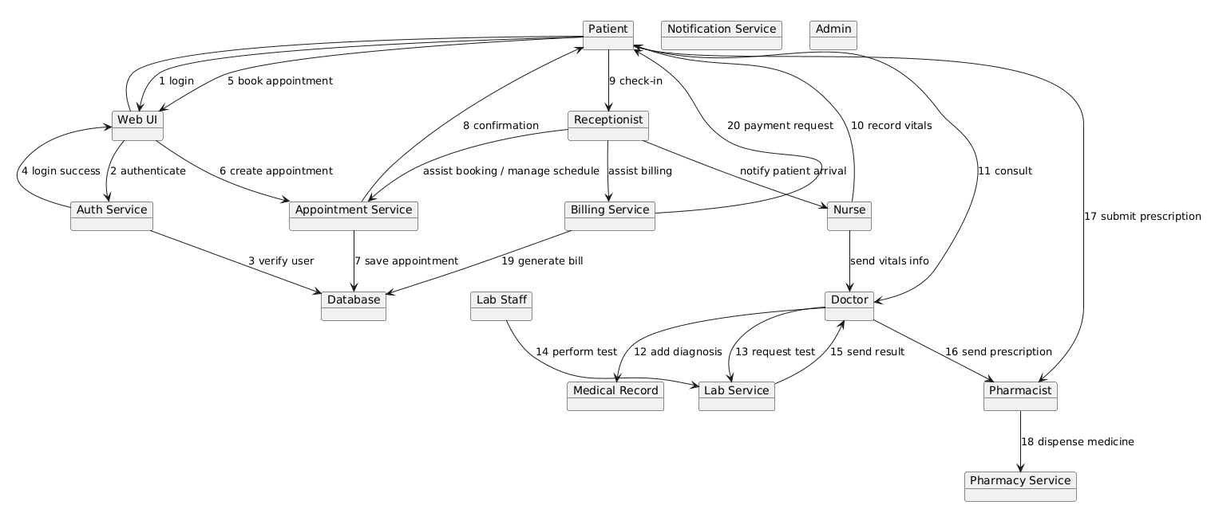

Table Design

REGISTRATION TABLE
Field Name | Data Type | Description
registration_id | INT (PK) | Unique registration ID
name | VARCHAR(100) | Full name of user
email | VARCHAR(100) | Email ID
phone | VARCHAR(15) | Mobile number
password | VARCHAR(255) | Encrypted password
user_type | VARCHAR(20) | Patient / Doctor / Staff
status | VARCHAR(20) | Pending / Approved / Rejected
registered_date | DATE | Registration date

USER TABLE (Base Entity for All Roles)
Attribute Name | Data Type | Description
user_id | INT (PK) | Unique user identifier
registration_id | INT (FK) | Links to Registration table
username | VARCHAR(50) | Login username
email | VARCHAR(100) | User email
password | VARCHAR(255) | Encrypted password
role | VARCHAR(20) | Admin / Patient / Doctor / Staff
status | VARCHAR(20) | Active / Inactive / Blocked
created_at | DATETIME | Account creation date
last_login | DATETIME | Last login time

PATIENT_PROFILE TABLE
Attribute Name | Data Type | Description
patient_id | INT (PK) | Unique patient ID
user_id | INT (FK) | Links to User table
patient_code | VARCHAR(20) | Hospital patient number
name | VARCHAR(100) | Patient full name
gender | VARCHAR(10) | Male / Female / Other
date_of_birth | DATE | Date of birth
blood_group | VARCHAR(5) | Blood group
phone | VARCHAR(15) | Contact number
address | TEXT | Address
registered_date | DATE | Registration date
status | VARCHAR(20) | Active / Inactive

PATIENT_MEDICAL_RECORD TABLE
Attribute Name | Data Type | Description
record_id | INT (PK) | Medical record ID
patient_id | INT (FK) | Links to patient_profile
visit_date | DATE | Date of visit
patient_type | VARCHAR(20) | Inpatient / Outpatient
diagnosis | TEXT | Doctor diagnosis
treatment | TEXT | Treatment given
prescription_id | INT (FK) | Prescription reference
lab_test_required | VARCHAR(10) | Yes / No
doctor_id | INT (FK) | Attending doctor
remarks | TEXT | Notes

DOCTOR TABLE
Column Name | Data Type | Description
doctor_id | INT (PK) | Unique doctor ID
user_id | INT (FK) | References User(user_id)
specialization | VARCHAR(100) | Medical specialization
qualification | VARCHAR(100) | Degree details
experience | INT | Years of experience
department | VARCHAR(100) | Department
date_of_join | DATE | Date of joining
designation | VARCHAR(50) | Doctor designation (Junior / Senior / Consultant)

NURSE TABLE
Column Name | Data Type | Description
nurse_id | INT (PK) | Unique nurse ID
user_id | INT (FK) | References User(user_id)
department | VARCHAR(100) | Assigned department
shift | VARCHAR(20) | Day / Night
qualification | VARCHAR(100) | Nursing qualification
experience | INT | Years of experience
date_of_join | DATE | Date of joining
designation | VARCHAR(50) | Staff Nurse / Senior Nurse
status | VARCHAR(20) | Active / On Leave

5️⃣ LAB STAFF TABLE
Column Name | Data Type | Description
labstaff_id | INT (PK) | Unique lab staff ID
user_id | INT (FK) | References User(user_id)
lab_type | VARCHAR(100) | Blood / X-Ray / Pathology
shift | VARCHAR(20) | Day / Night
qualification | VARCHAR(100) | Educational qualification
experience | INT | Years of experience
date_of_join | DATE | Date of joining
designation | VARCHAR(50) | Technician / Senior Technician
status | VARCHAR(20) | Active / On Leave

PHARMACIST TABLE
Column Name | Data Type | Description
pharmacist_id | INT (PK) | Unique pharmacist ID
user_id | INT (FK) | References User(user_id)
qualification | VARCHAR(100) | Pharmacy qualification
experience | INT | Years of experience
shift | VARCHAR(20) | Day / Night
date_of_join | DATE | Date of joining
designation | VARCHAR(50) | Pharmacist / Senior Pharmacist
status | VARCHAR(20) | Active / On Leave

CANTEEN STAFF TABLE
Column Name | Data Type | Description
canteenstaff_id | INT (PK) | Unique canteen staff ID
user_id | INT (FK) | References User(user_id)
role | VARCHAR(50) | Cook / Cashier / Helper
shift | VARCHAR(20) | Morning / Evening
date_of_join | DATE | Date of joining
status | VARCHAR(20) | Active / On Leave

RECEPTIONIST TABLE
Column Name | Data Type | Description
receptionist_id | INT (PK) | Unique receptionist ID
user_id | INT (FK) | References User(user_id)
desk_no | VARCHAR(20) | Reception desk number
shift | VARCHAR(20) | Day / Night
experience | INT | Years of experience
qualification | VARCHAR(100) | Educational qualification
date_of_join | DATE | Date of joining
language_known | VARCHAR(100) | Languages known
status | VARCHAR(20) | Active / On Leave

9️⃣ APPOINTMENT TABLE
Column Name | Data Type | Description
appointment_id | INT (PK) | Unique appointment ID
patient_id | INT (FK) | References Patient(patient_id)
doctor_id | INT (FK) | References Doctor(doctor_id)
department | VARCHAR(100) | Department of consultation
appointment_date | DATE | Appointment date
appointment_time | TIME | Appointment time
appointment_type | VARCHAR(20) | Online / Walk-in
status | ENUM | Requested / Confirmed / Completed / Cancelled
queue_number | INT | Token / queue number
payment_status | VARCHAR(20) | Pending / Paid
created_at | DATETIME | Booking time
remarks | TEXT | Notes

🔟 MEDICAL RECORD TABLE
Column Name | Data Type | Description
record_id | INT (PK) | Unique medical record
patient_id | INT (FK) | References Patient(patient_id)
doctor_id | INT (FK) | Attending doctor
appointment_id | INT (FK) | Related appointment
diagnosis | TEXT | Diagnosis details
treatment | TEXT | Treatment given
prescription_id | INT (FK) | Prescription reference
lab_test_required | VARCHAR(10) | Yes / No
follow_up_date | DATE | Next visit date
record_status | VARCHAR(20) | Open / Closed

PRESCRIPTION TABLE
Column Name | Data Type | Description
prescription_id | INT (PK) | Unique prescription ID
patient_id | INT (FK) | References Patient(patient_id)
doctor_id | INT (FK) | Prescribing doctor
prescription_date | DATE | Date of prescription
medicine_details | TEXT | Medicines prescribed
dosage | TEXT | Dosage instructions
duration | VARCHAR(50) | Duration of medication
instructions | TEXT | Special instructions

LAB TEST TABLE
Column Name | Data Type | Description
labtest_id | INT (PK) | Unique lab test ID
patient_id | INT (FK) | References Patient(patient_id)
doctor_id | INT (FK) | Doctor who requested test
test_name | VARCHAR(100) | Name of lab test
test_type | VARCHAR(50) | Blood / X-Ray / Scan / Pathology
sample_collected | VARCHAR(10) | Yes / No
test_date | DATE | Date of test
result | TEXT | Test result
report_date | DATE | Report generated date
labstaff_id | INT (FK) | Lab staff handling test
status | VARCHAR(20) | Pending / In Progress / Completed

1️⃣3️⃣ BILLING TABLE
Column Name | Data Type | Description
bill_id | INT (PK) | Unique bill ID
patient_id | INT (FK) | References Patient(patient_id)
appointment_id | INT (FK) | Related appointment
bill_type | VARCHAR(50) | OP / IP / Lab / Pharmacy
total_amount | DECIMAL(10,2) | Total bill amount
Doctor_id | INT(FK) | References Doctor(doctor_id)
payment_mode | VARCHAR(30) | Cash / Card / UPI / Online
payment_status | ENUM | Pending / Paid / Failed
bill_date | DATE | Billing date

REPORT TABLE
Column Name | Data Type | Description
report_id | INT (PK) | Unique report ID
patient_id | INT (FK) | References Patient(patient_id)
report_type | VARCHAR(100) | Lab / Medical / Radiology / Pathology / Prescription
generated_date | DATE | Report generation date
doctor_id | INT (FK) | References Doctor(doctor_id), the doctor who requested/generated the report
lab_id | INT (FK) | References Lab(lab_id), if it is a lab-related report
diagnosis | TEXT | Diagnosis mentioned in the report (if applicable)
status | VARCHAR(50) | Pending / Completed / Reviewed
report_file | VARCHAR(255) | File path or URL if the report is stored digitally

PAYMENT TABLE
Column Name | Data Type | Description
payment_id | INT (PK) | Unique payment ID
bill_id | INT (FK) | References Billing(bill_id)
patient_id | INT (FK) | References Patient(patient_id), for easy patient lookup
payment_date | DATE | Date of payment
payment_method | VARCHAR(50) | Cash / Card / UPI / Net Banking / Insurance
payment_amount | DECIMAL(10,2) | Amount paid
payment_status | ENUM | Success / Pending / Failed
transaction_id | VARCHAR(100) | Bank or payment gateway transaction reference

TABLE NORMALIZATION (1NF → 2NF → 3NF)

UNNORMALIZED FORM (UNF)
A single table containing patient details, doctor details, appointments, prescriptions, lab reports, billing, and feedback.
Problems:
- Data redundancy
- Repeating groups
- Update and deletion anomalies

FIRST NORMAL FORM (1NF)
- All attributes contain atomic values
- Repeating groups removed
- Separate tables created for Users, Appointments, Medical Records, Lab Tests, Billing, and Feedback

SECOND NORMAL FORM (2NF)
- Partial dependencies removed
- Patient details moved to PATIENTS table
- Doctor details moved to DOCTORS table
- Appointment table contains only appointment-related attributes

THIRD NORMAL FORM (3NF)
- Transitive dependencies removed
- User authentication details stored only in USERS table
- All non-key attributes depend only on the primary key

